**Phase-5 Practice Project: Assisted Practice -**

# 1.Launch and Connect to an EC2 Linux Instance

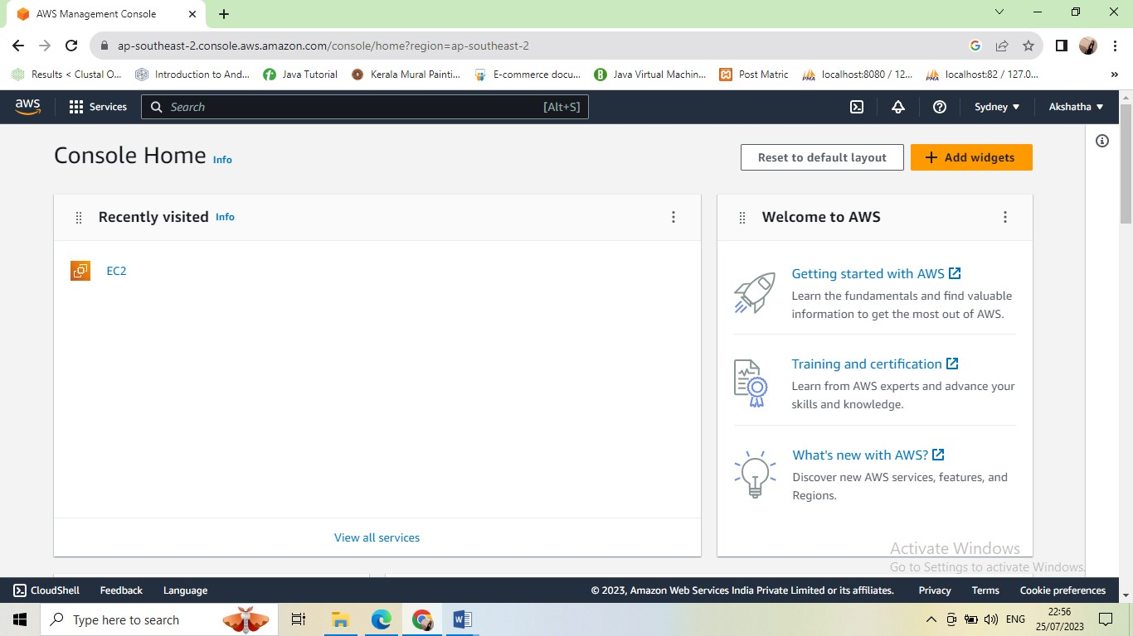

● Click on *launch instance* to run any instance

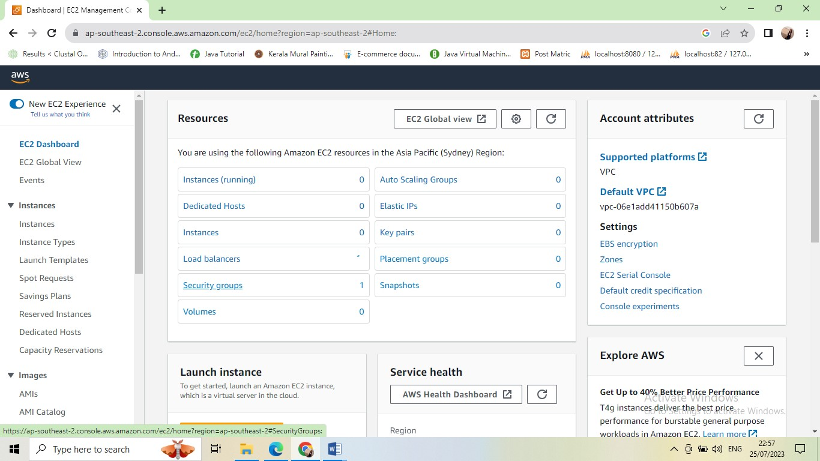

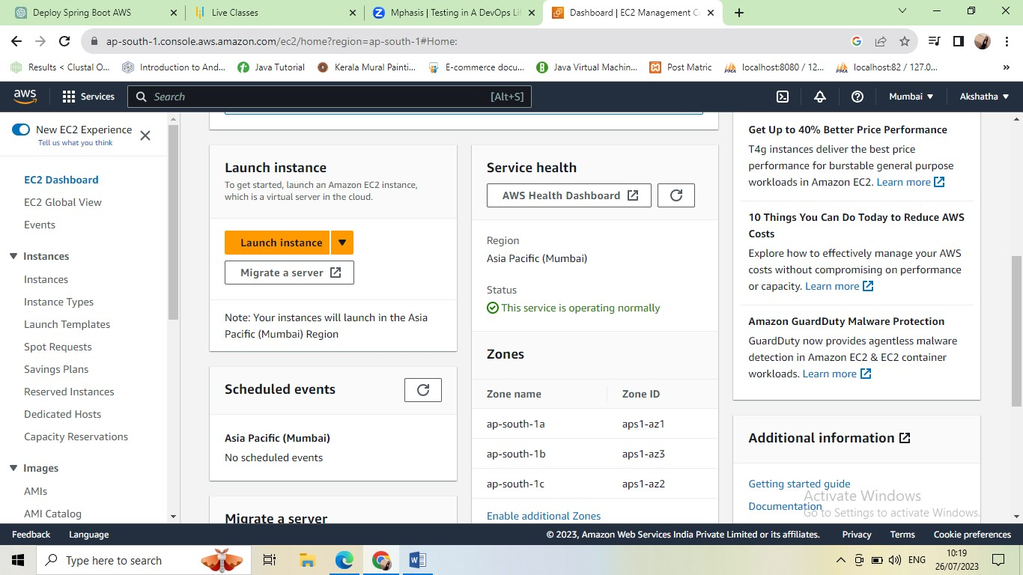

* Click on launch instance

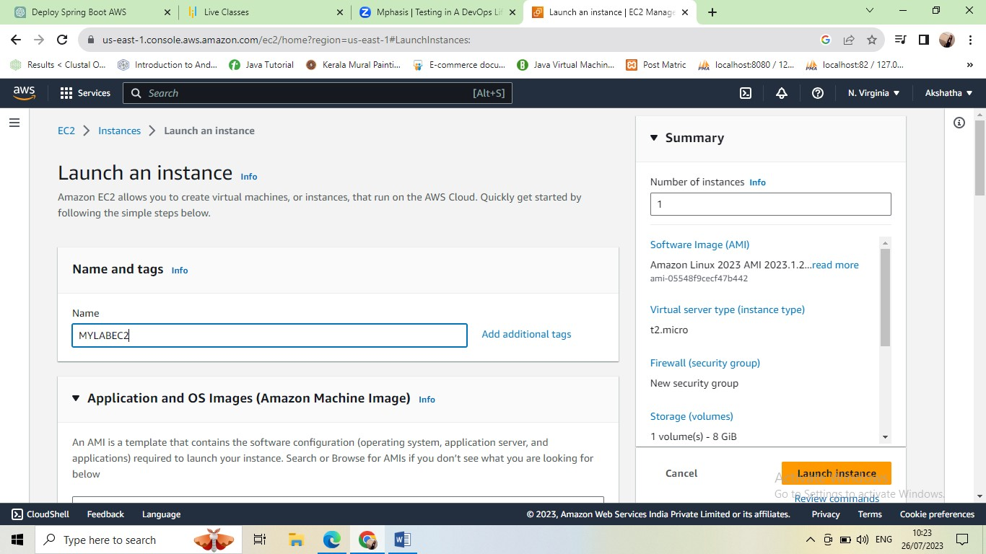

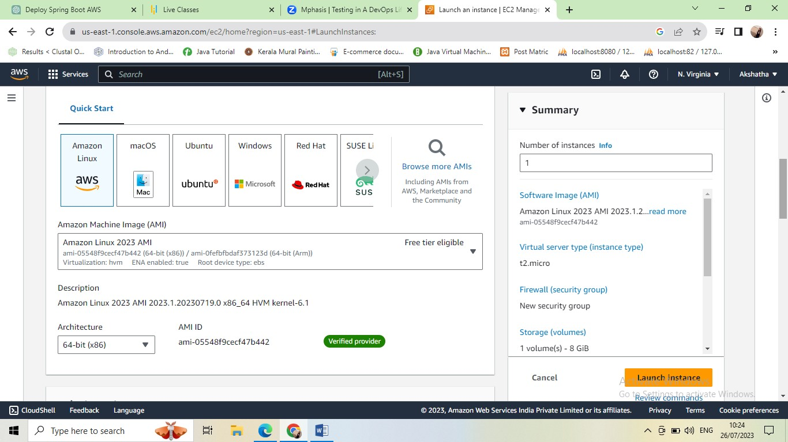

* Here click on amazon linux

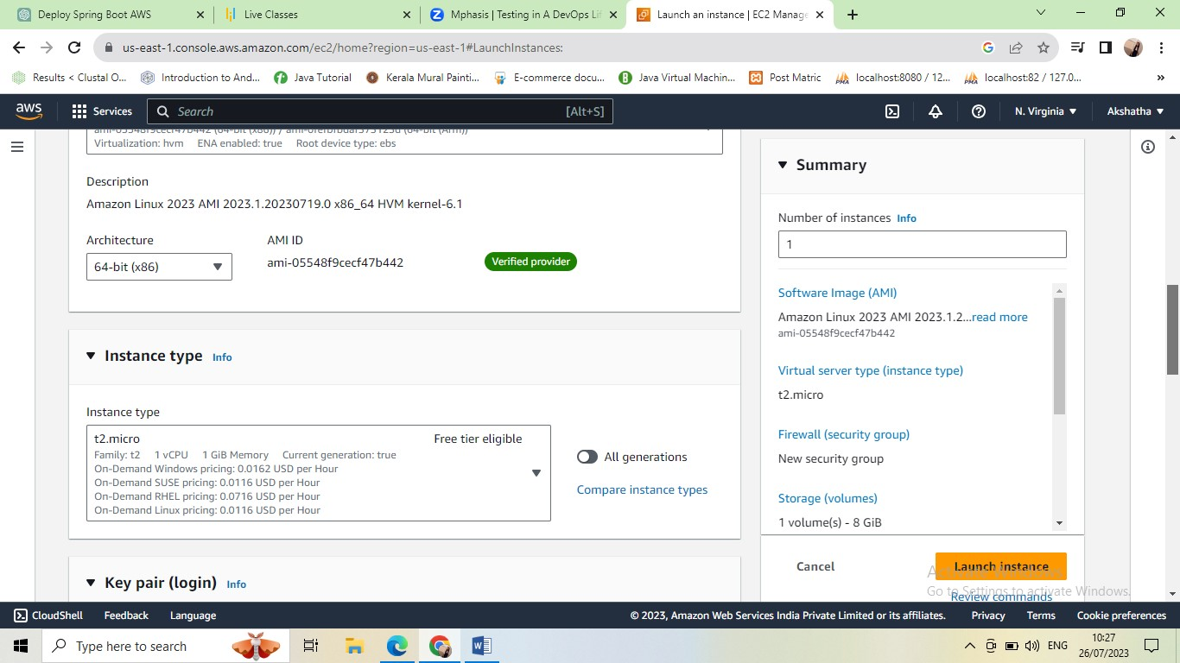

* Here creating instance type t2.micro after step
* Keypair login
* Creating new pair

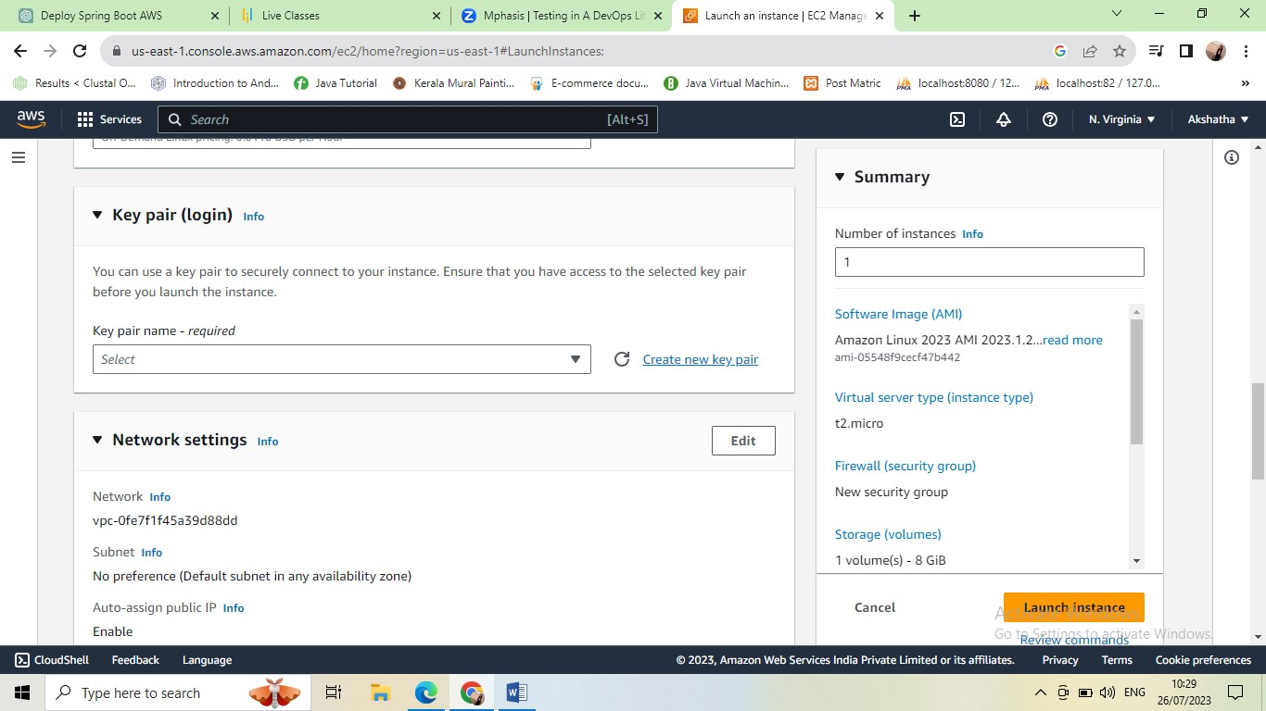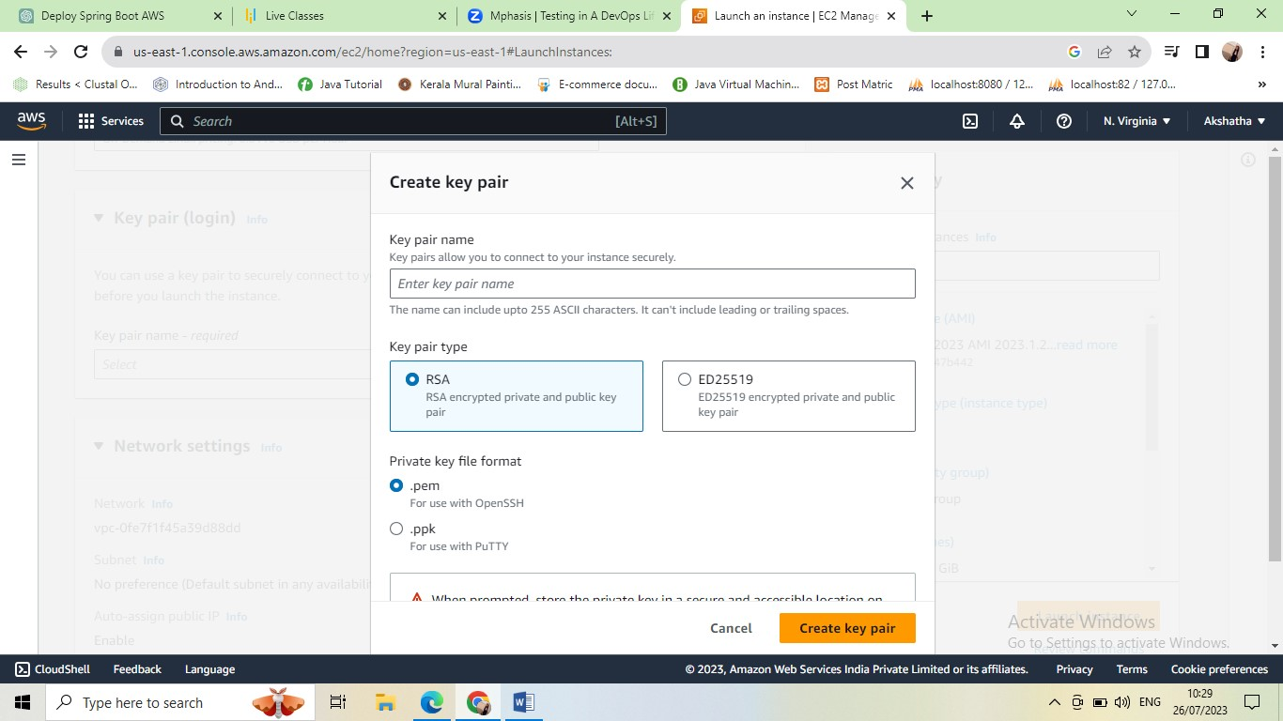

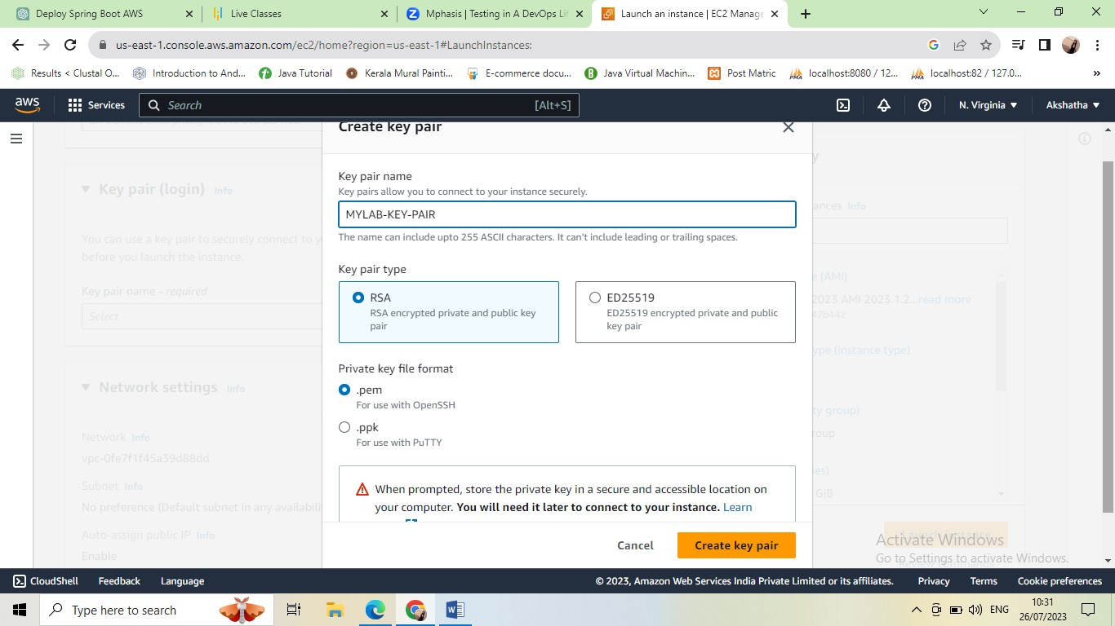

* Click on create key pair after downloading file in your system.

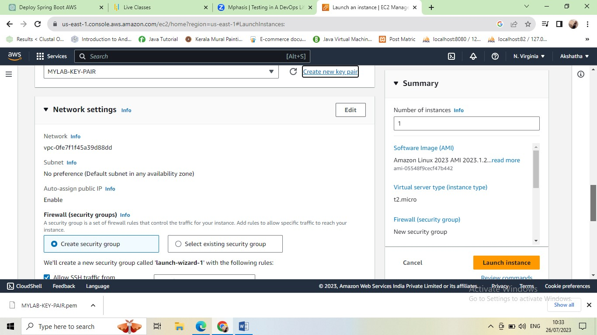

* Default setting nothing any change in this network settings

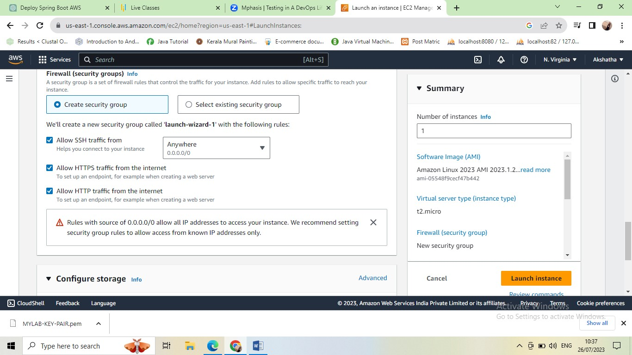

* Select all ssh traffic from ,allow https traffic from the internet ,allow http traffic from the internet

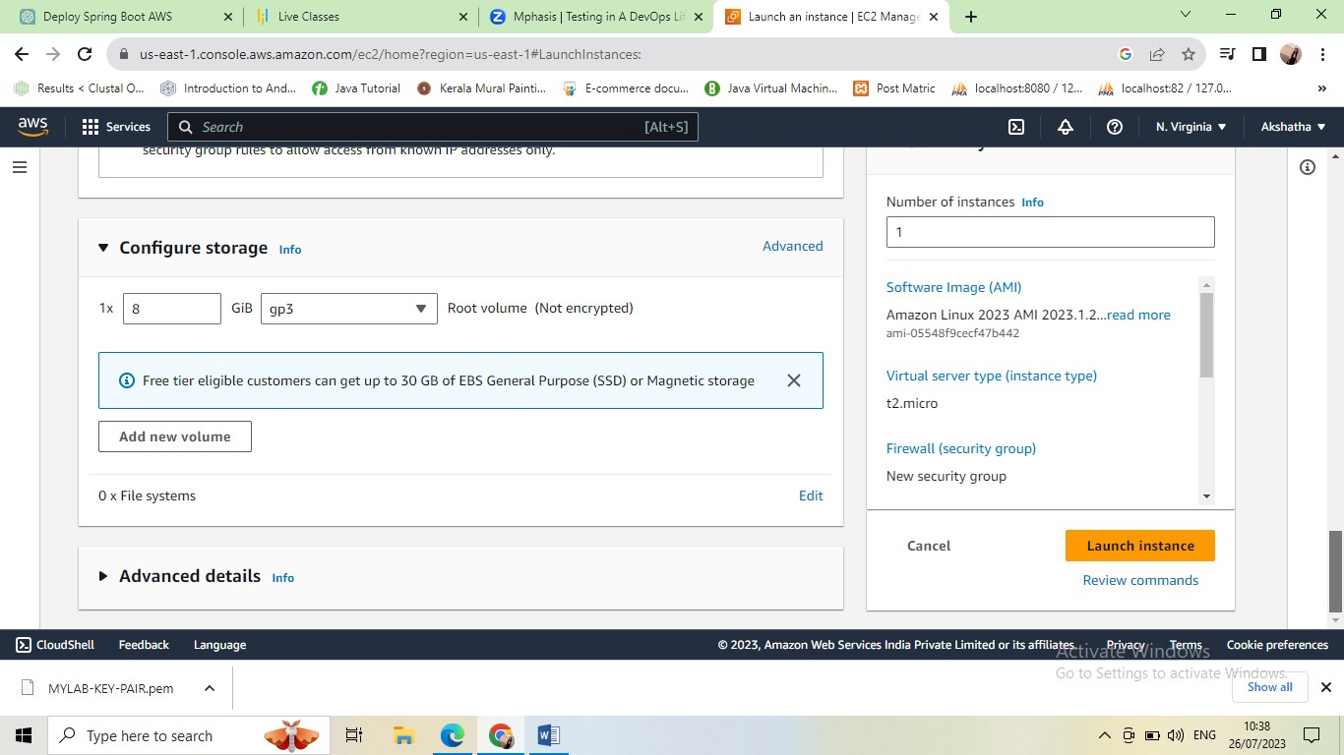

* Default nothing any change here

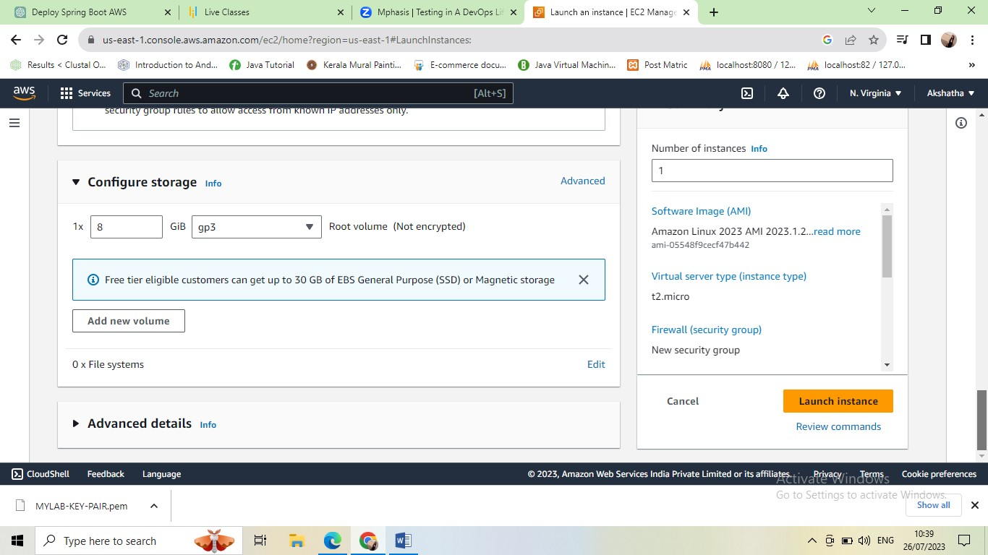

* Click on launch instance

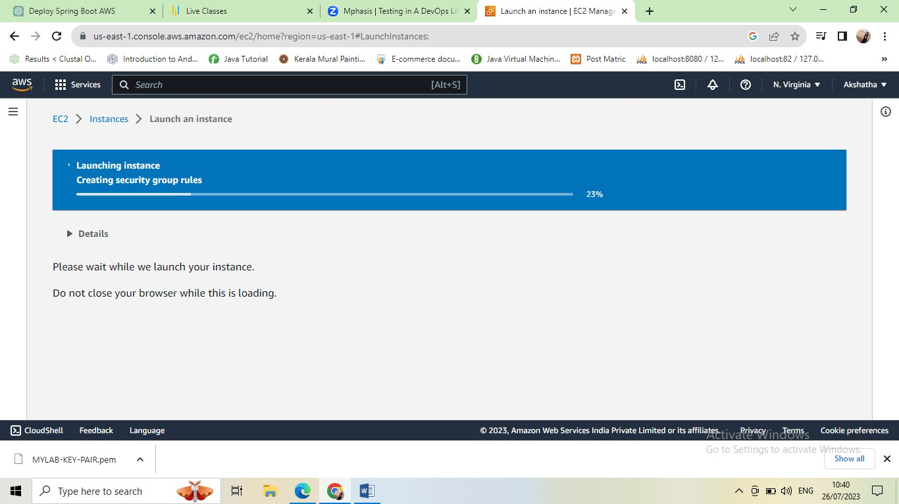

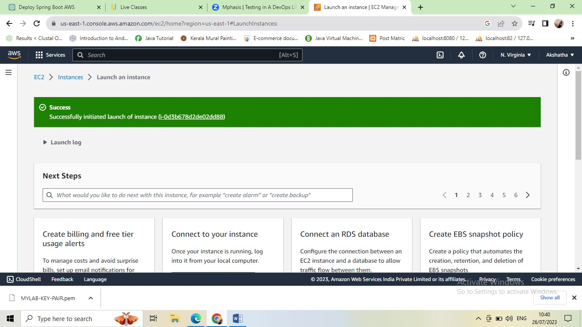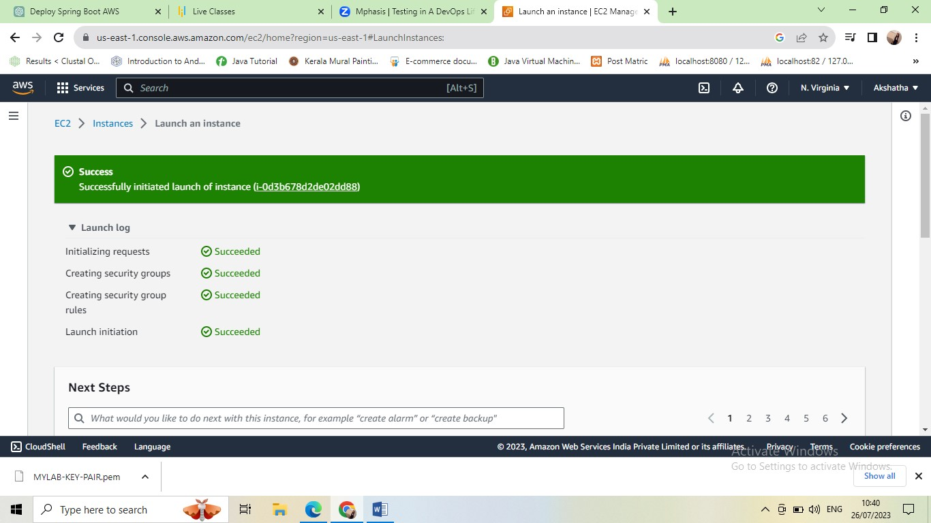

Click on these link

[(](https://us-east-1.console.aws.amazon.com/ec2/home?region=us-east-1#Instances:instanceId=i-0d3b678d2de02dd88)

[i](https://us-east-1.console.aws.amazon.com/ec2/home?region=us-east-1#Instances:instanceId=i-0d3b678d2de02dd88)

[-](https://us-east-1.console.aws.amazon.com/ec2/home?region=us-east-1#Instances:instanceId=i-0d3b678d2de02dd88)

[0](https://us-east-1.console.aws.amazon.com/ec2/home?region=us-east-1#Instances:instanceId=i-0d3b678d2de02dd88)

[d3b678d2de02dd](https://us-east-1.console.aws.amazon.com/ec2/home?region=us-east-1#Instances:instanceId=i-0d3b678d2de02dd88)

[8](https://us-east-1.console.aws.amazon.com/ec2/home?region=us-east-1#Instances:instanceId=i-0d3b678d2de02dd88)

[8](https://us-east-1.console.aws.amazon.com/ec2/home?region=us-east-1#Instances:instanceId=i-0d3b678d2de02dd88)

[)](https://us-east-1.console.aws.amazon.com/ec2/home?region=us-east-1#Instances:instanceId=i-0d3b678d2de02dd88)

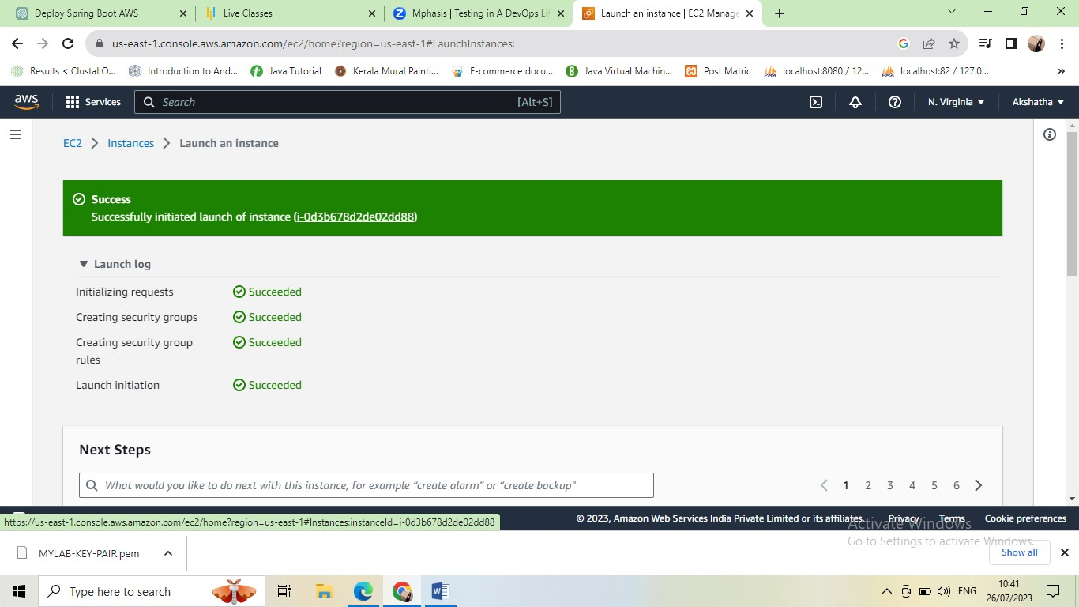

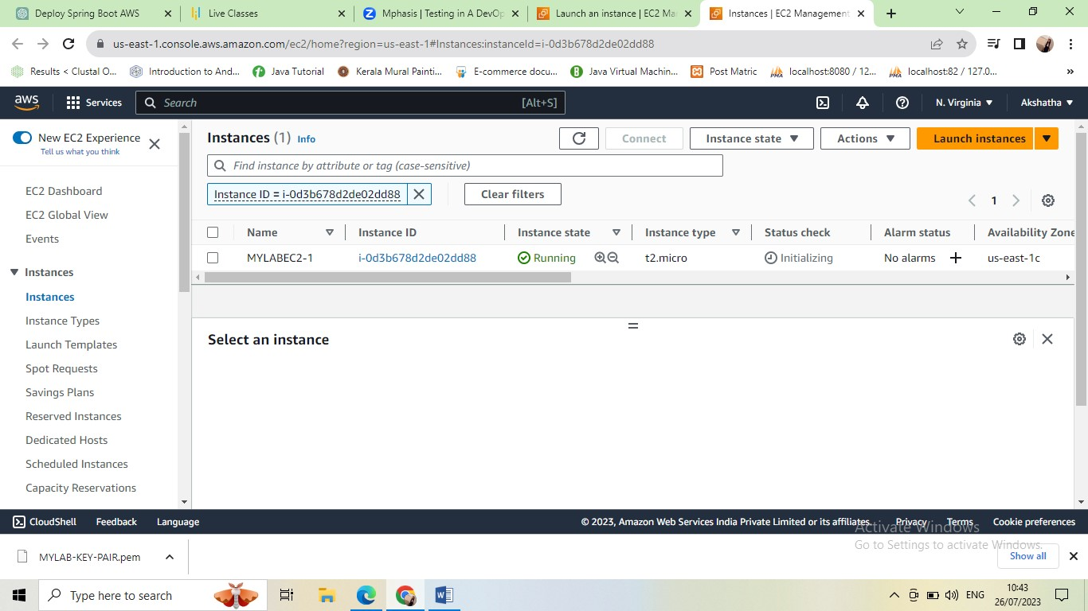

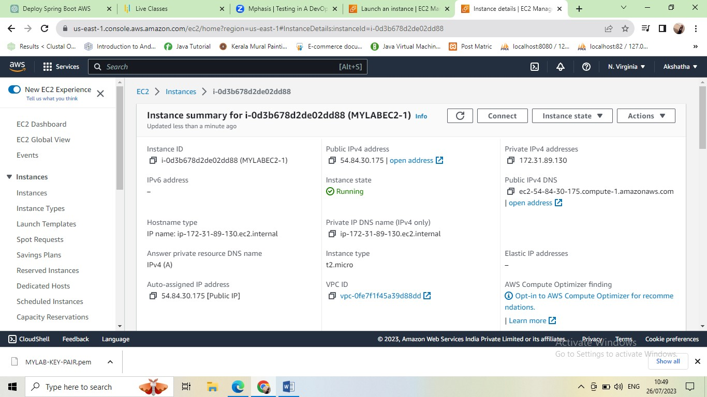

* Here Public IPv4 address : 54.84.30.175
* Private IPv4 addresses: 172.31.89.130

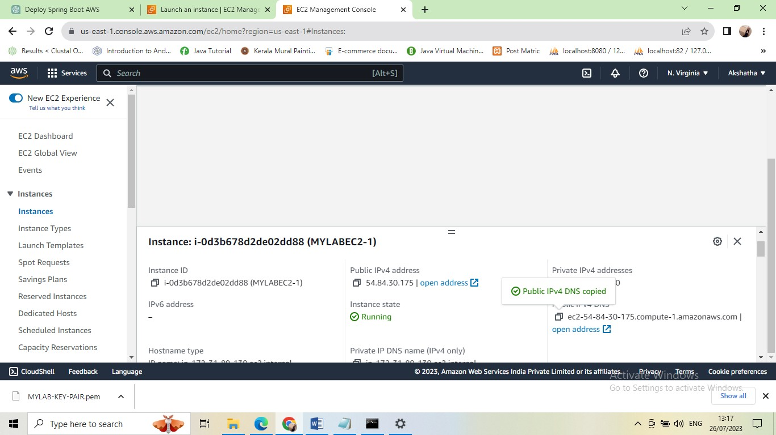

* ec2-54-84-30-175.compute-1.amazonaws.com

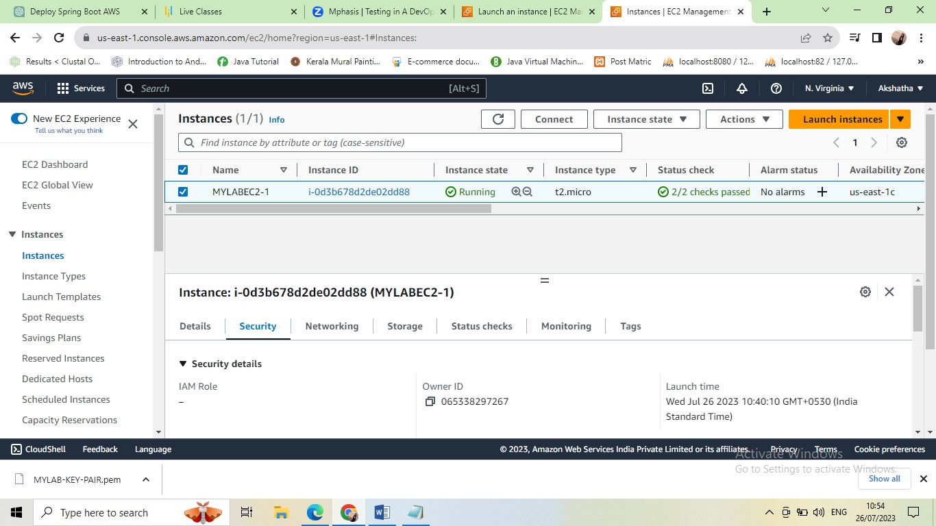

* Click on security

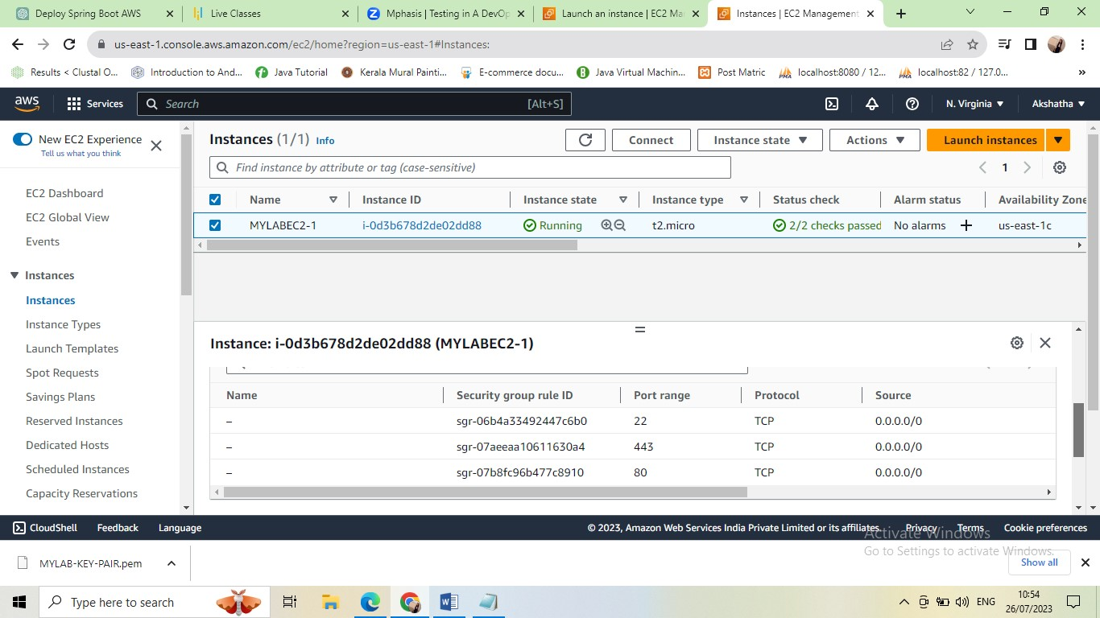

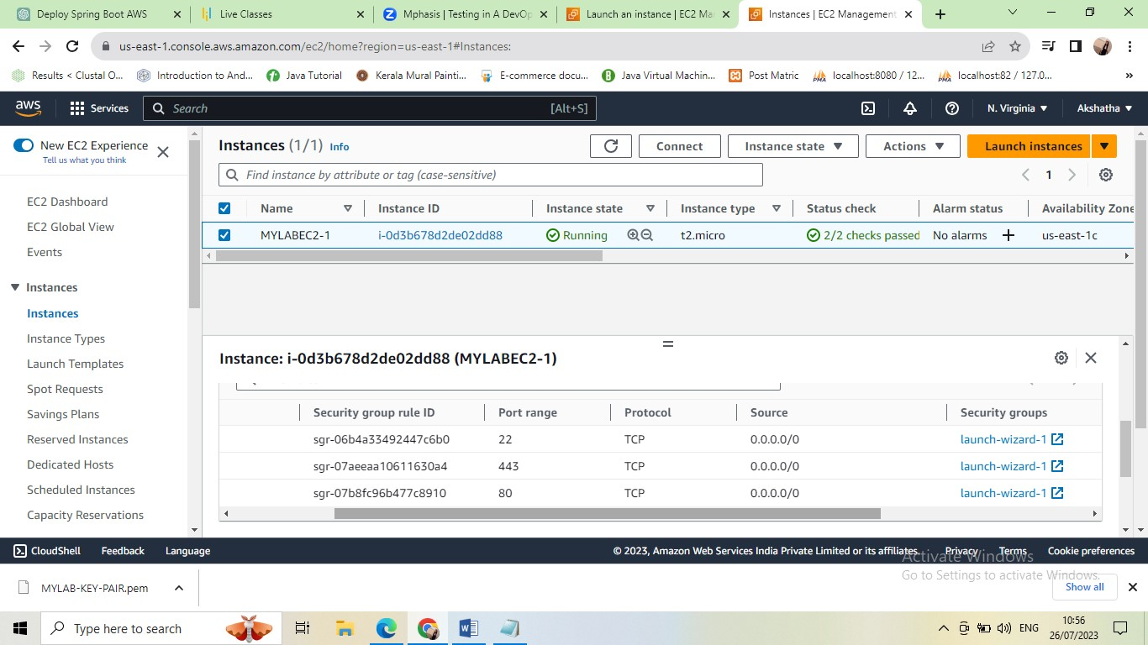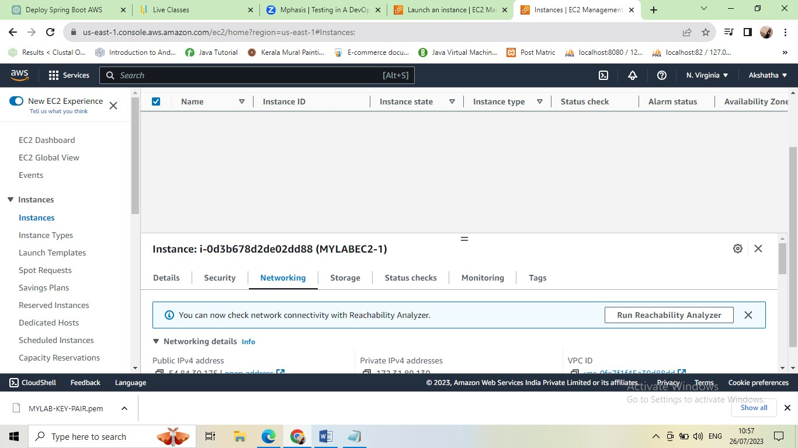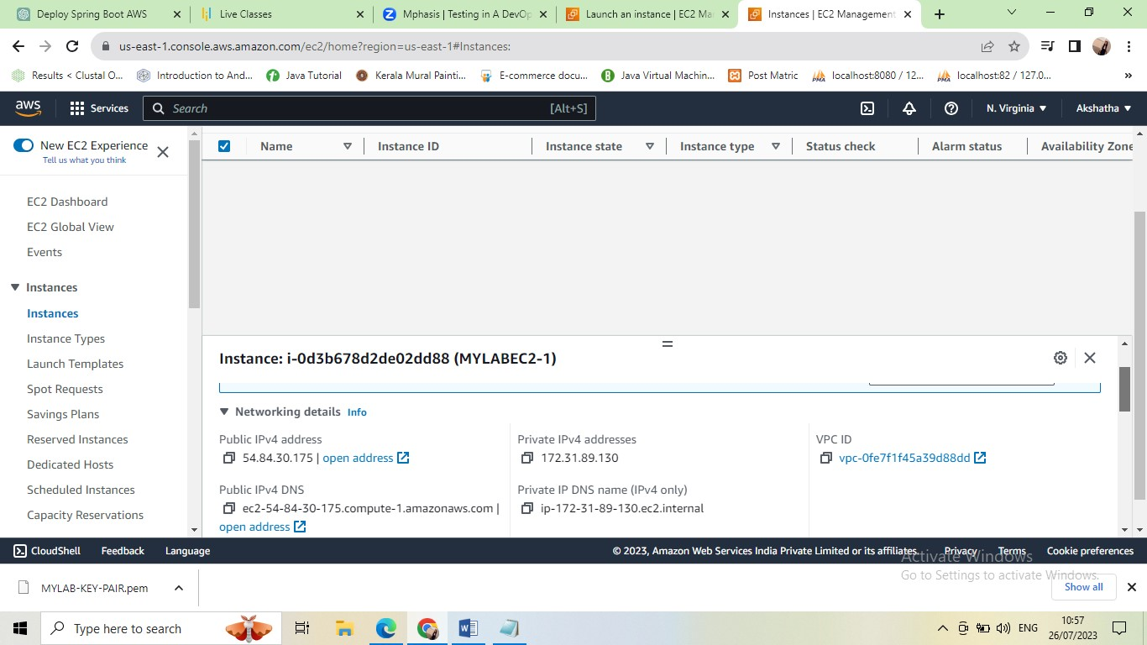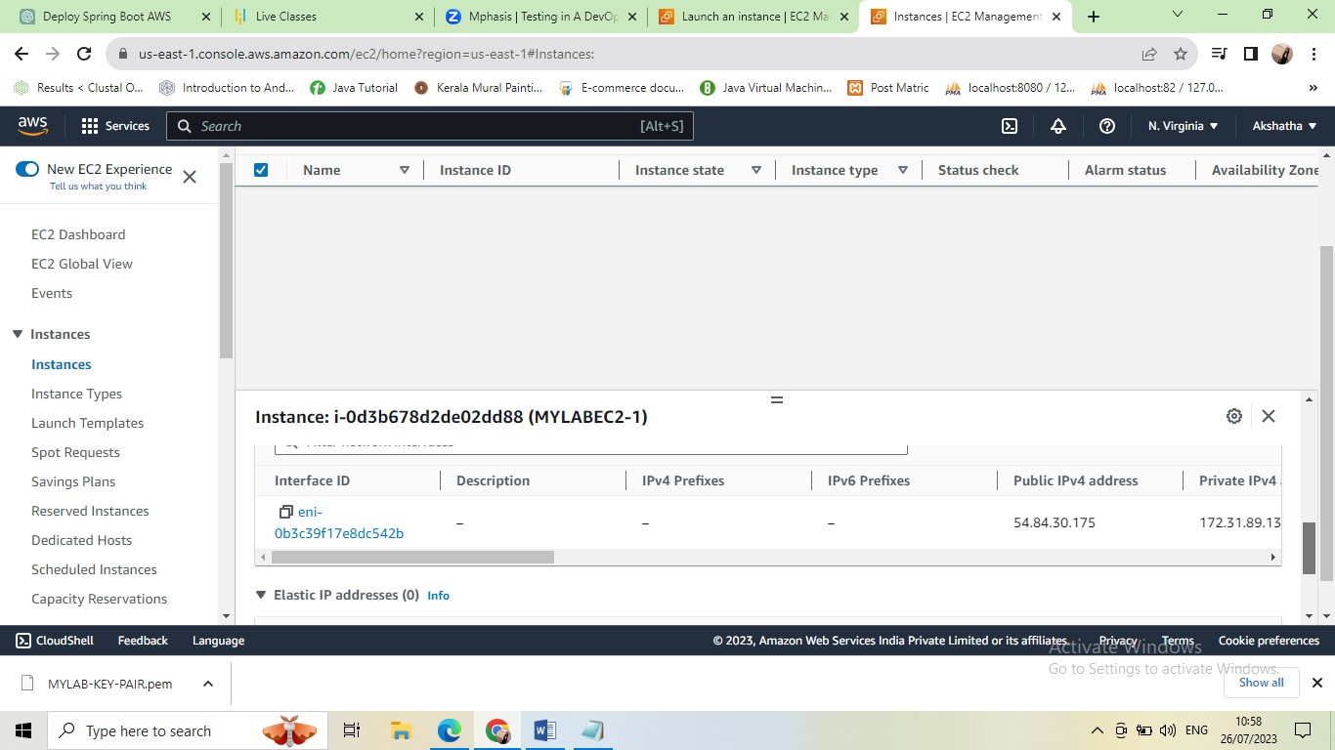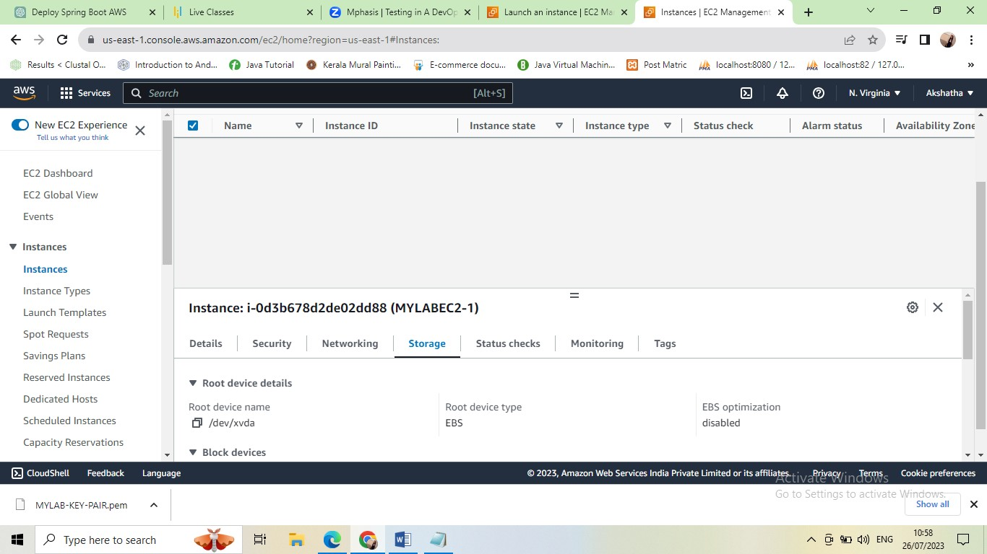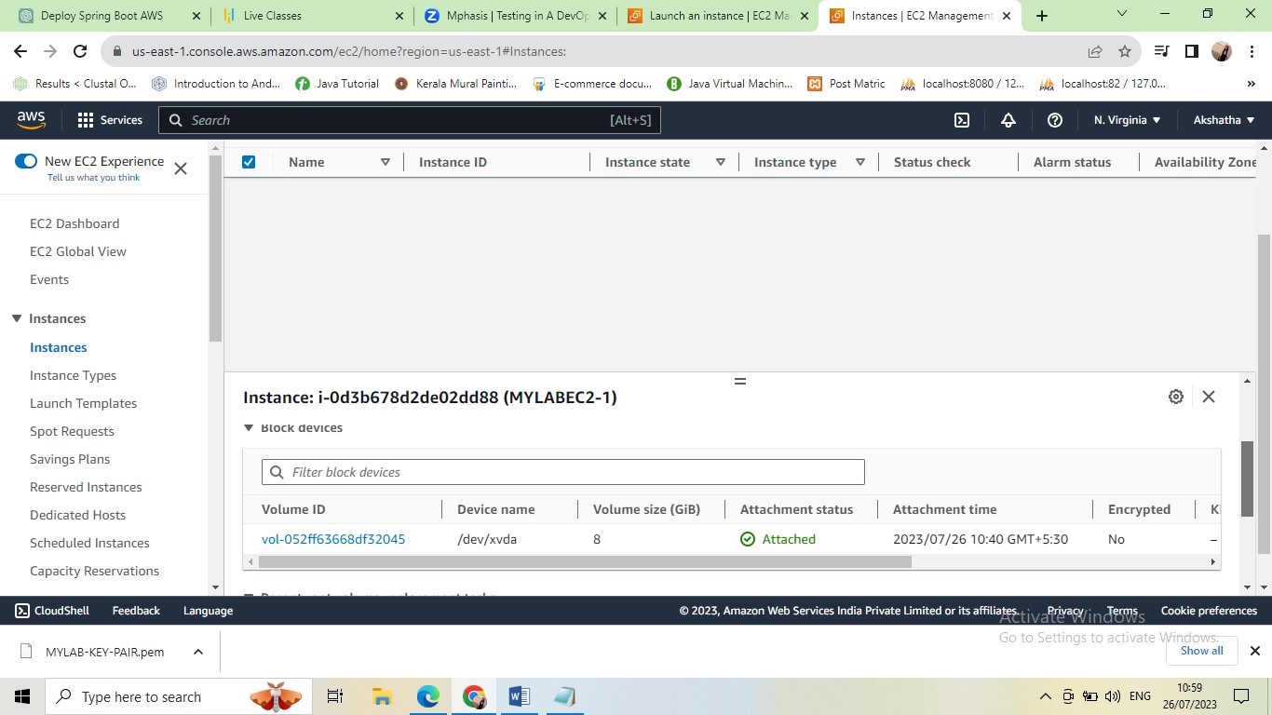

* Networking

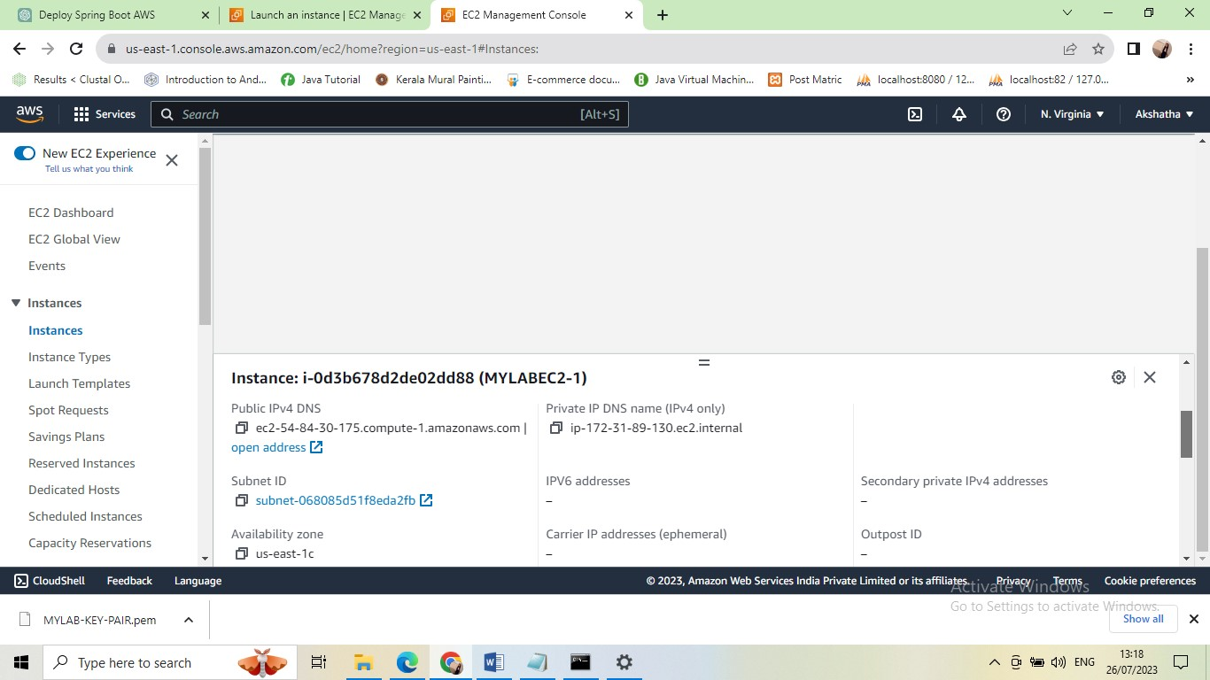

* Click on Subnet ID

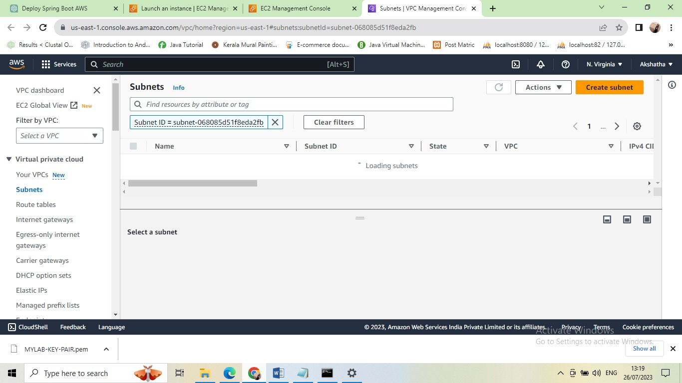

* Click on check box

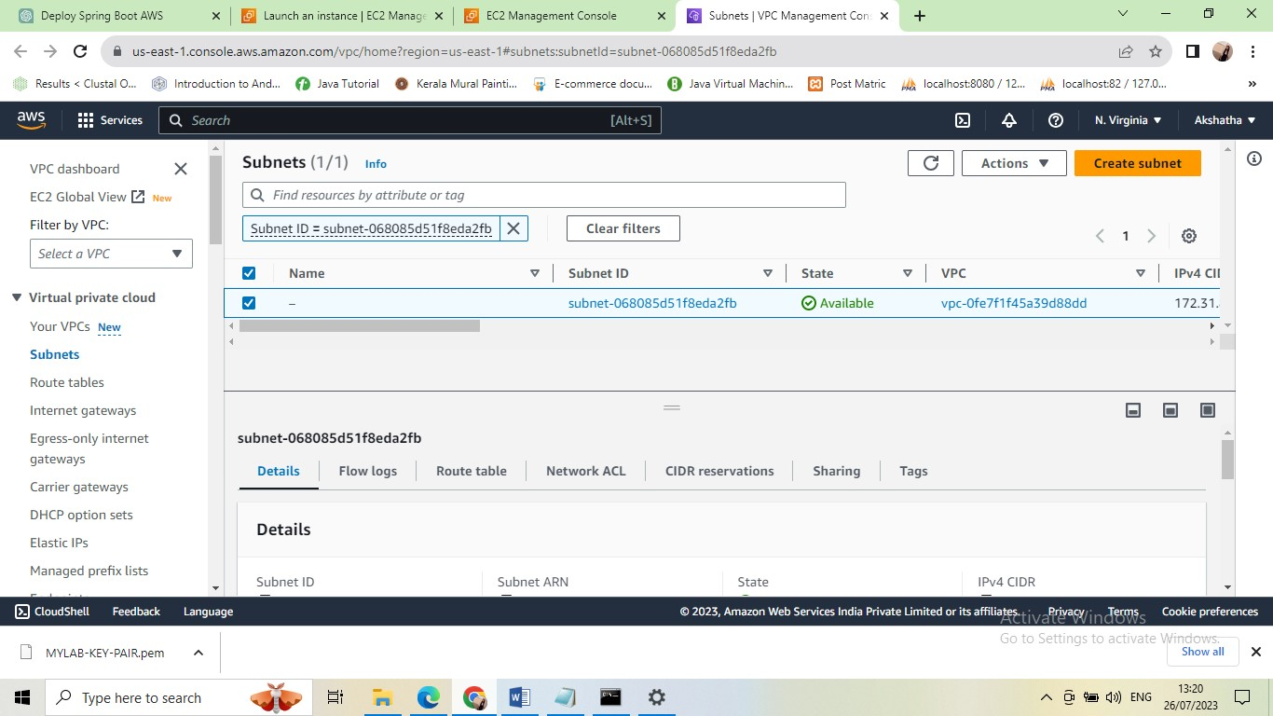

* Click on route table
* Route table
* [rtb-031692a5fc249dafe](https://us-east-1.console.aws.amazon.com/vpc/home?region=us-east-1#RouteTables:routeTableId=rtb-031692a5fc249dafe)

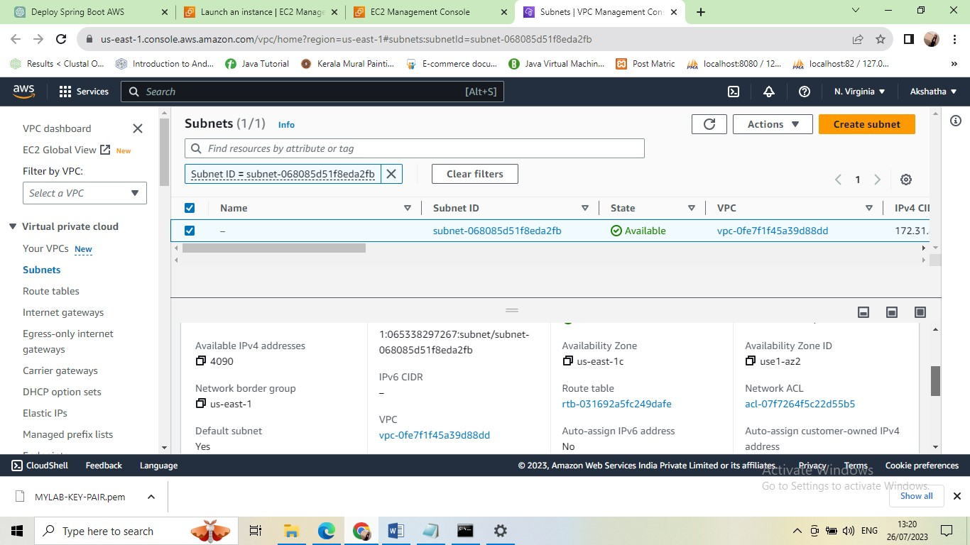

* Click on route table after

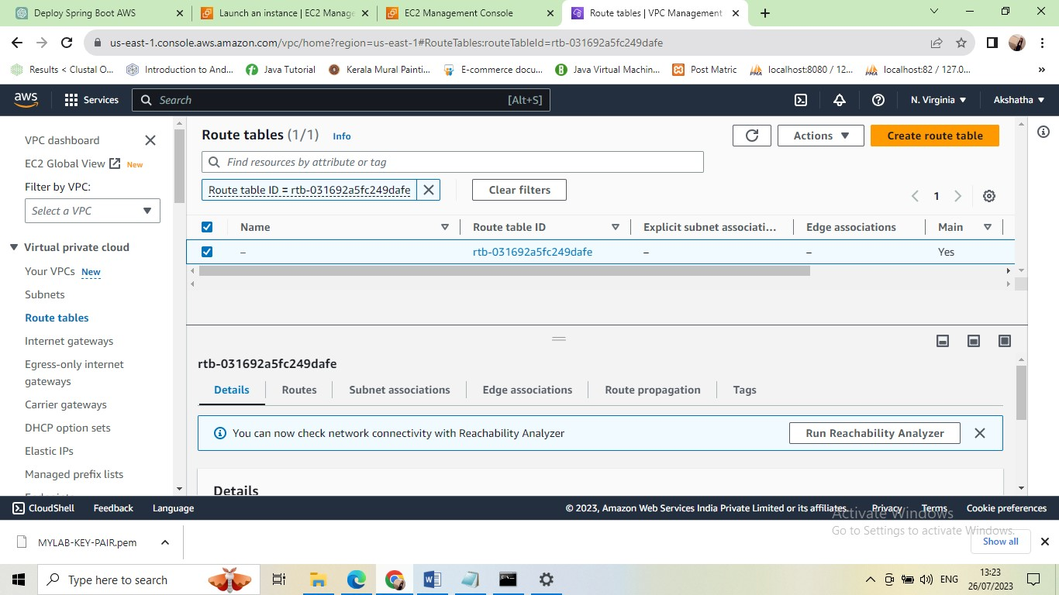

* Click on routes

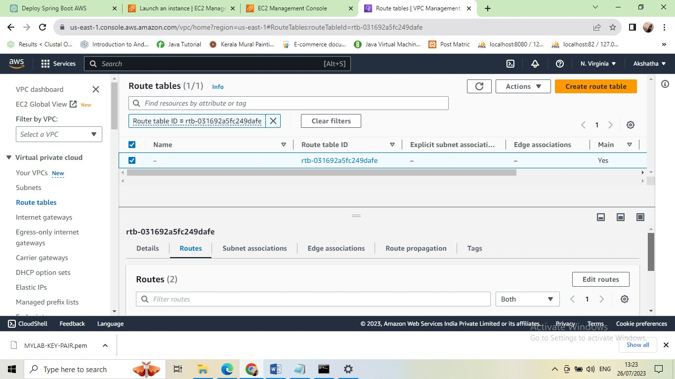

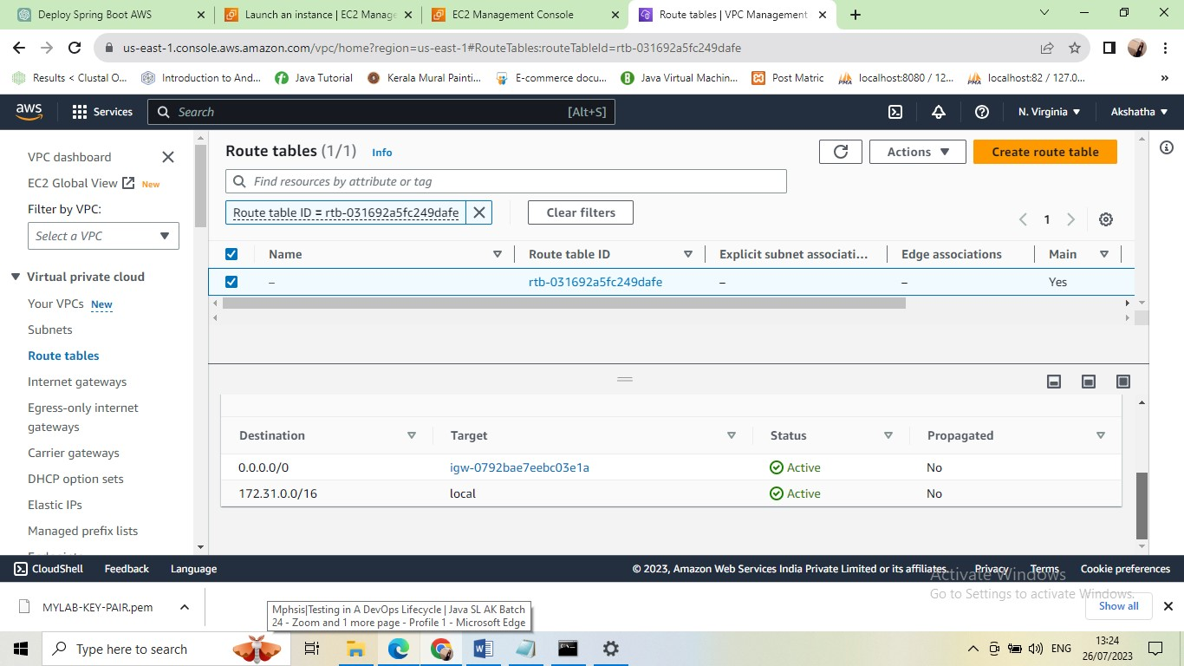

* Open command prompt

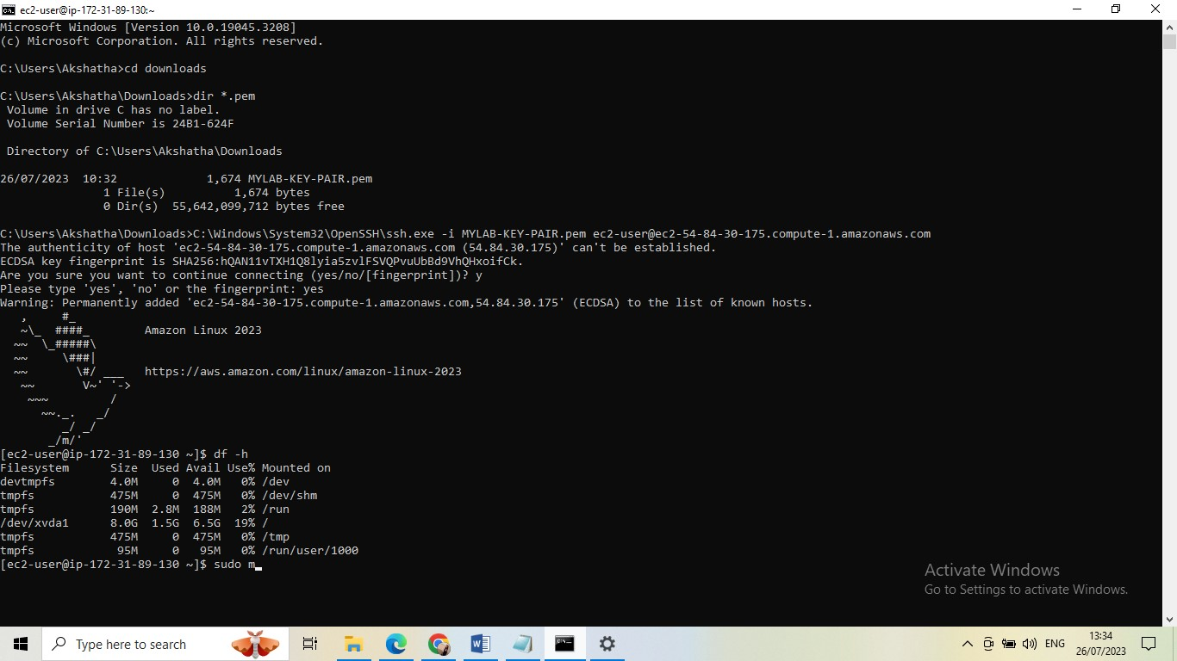

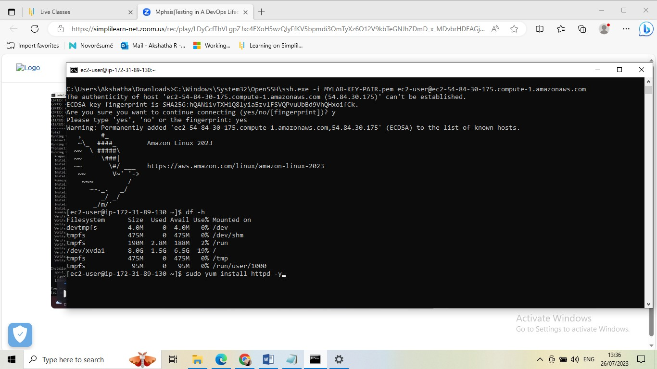 sudo vi /var/www/html/index.html

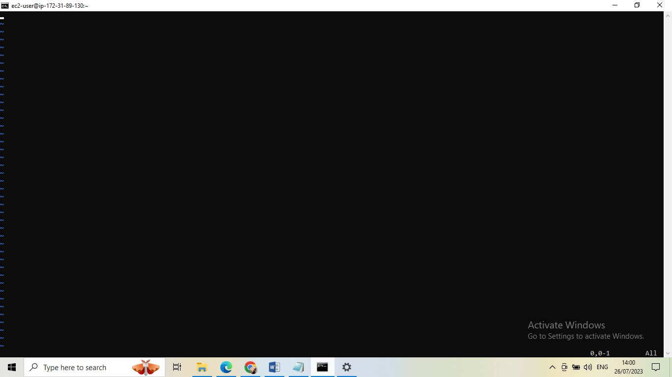

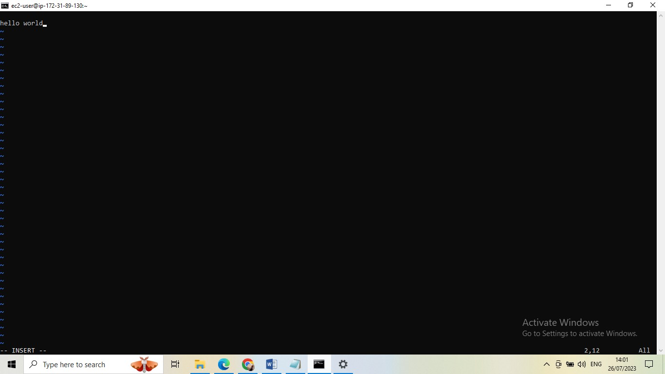

* Press escape key

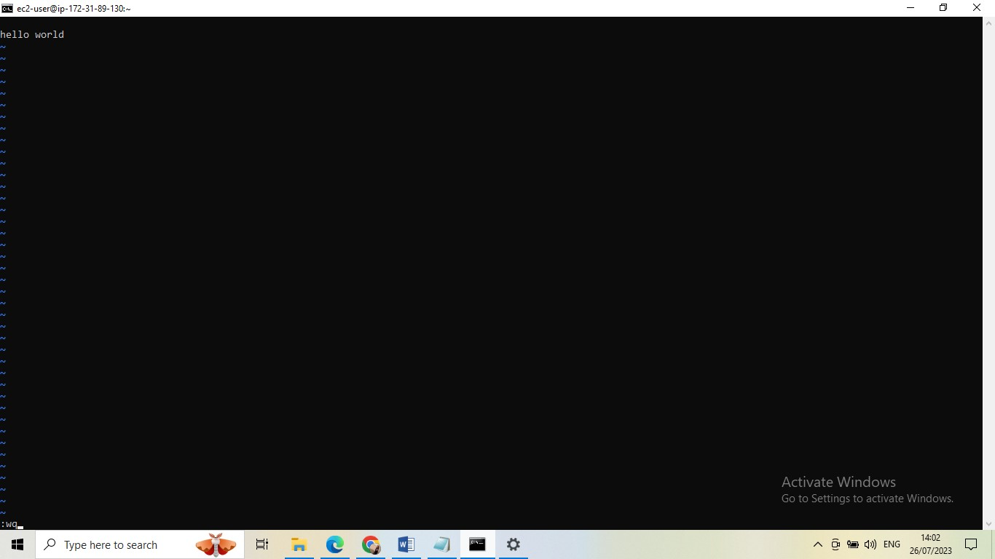

* Click on enter

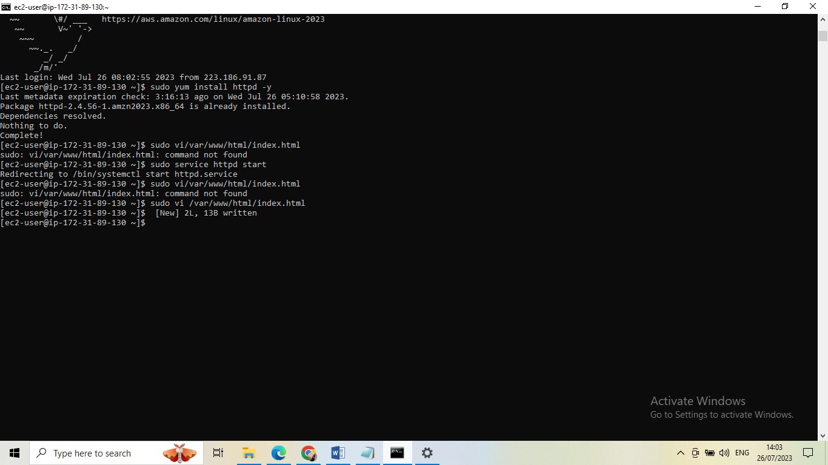 sudo service httpd start

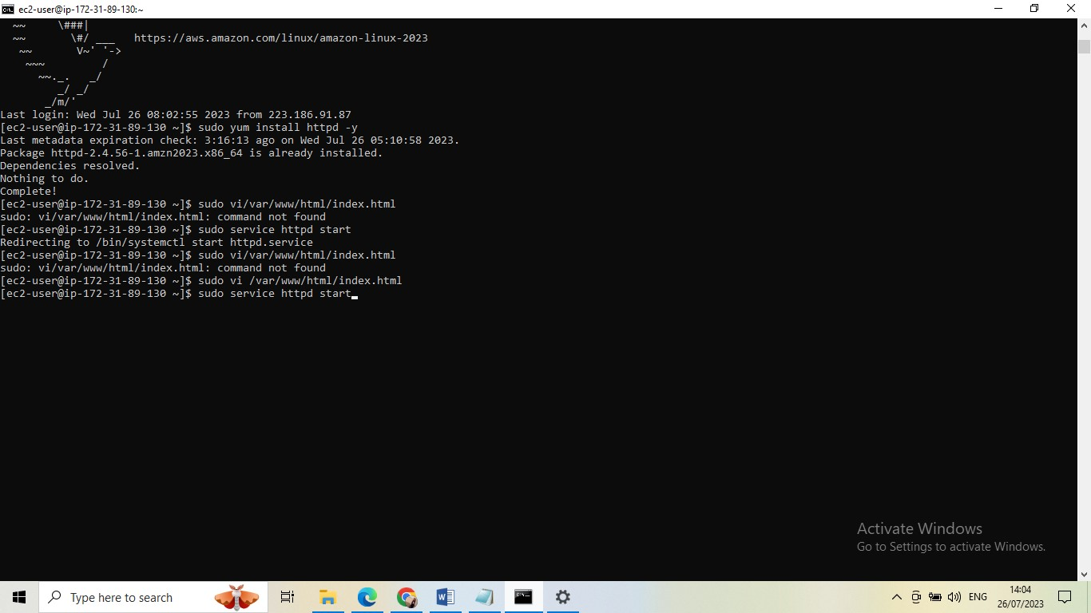 systemctl status httpd

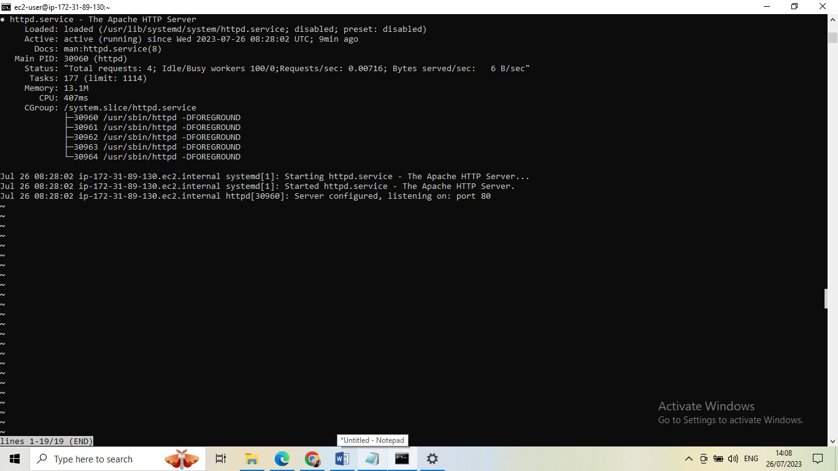

* Click public address

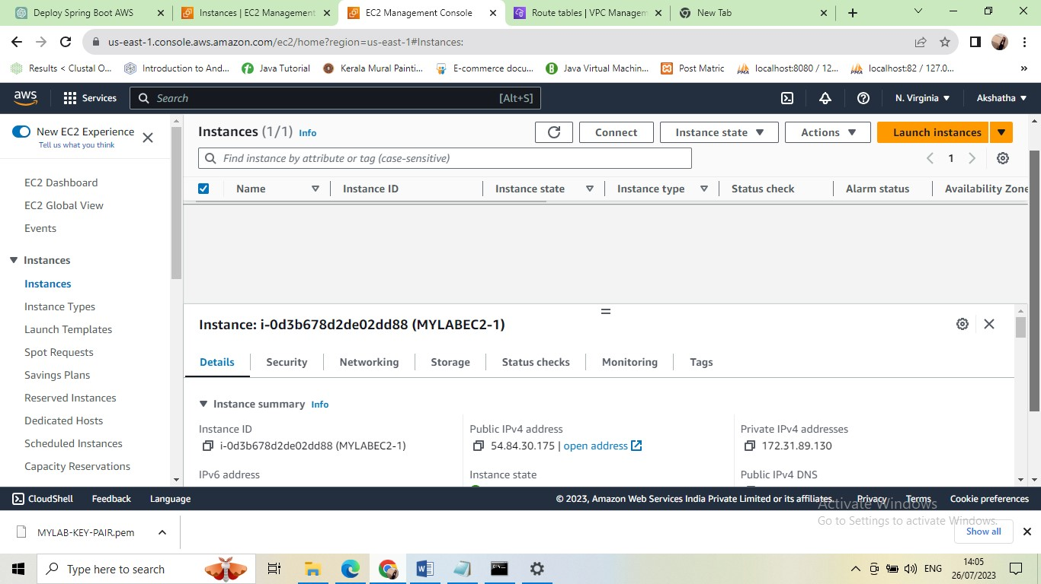

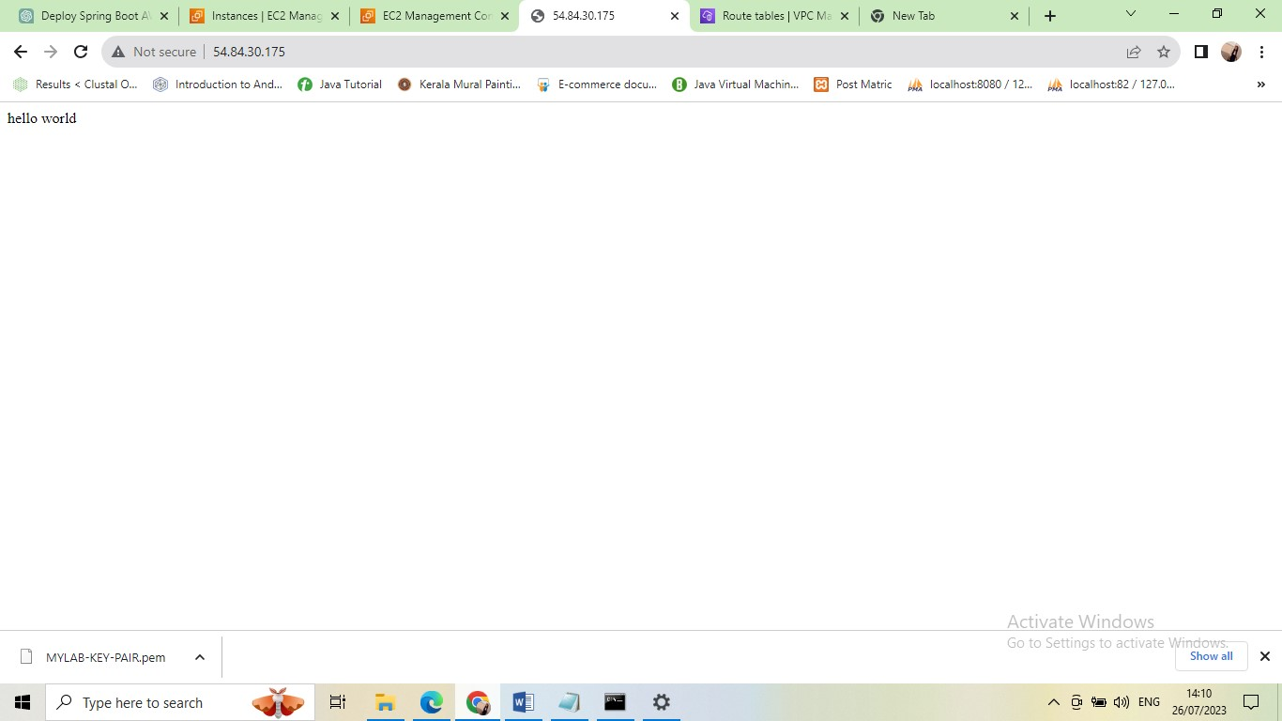

* Here we are given url http://54.84.30.175/